The application I am proposing is a task scheduling application meant to assist students in attending classes, completing assignments and doing all other academic related tasks. All academic activities have deadlines. Some deadlines are short, others are longsome assignments are individual based while others are done as groups. The application therefore lets a student schedule tasks such as assignments and group work. The student can then indicate the deadline of each of the assignments and the application will keep reminding the student until the task is marked as completed. This application therefore creates a sense of orderliness while approaching academics. In addition to scheduling the task, users can also mark the tasks in order of priority and this will ensure that the application treats such task as more urgent than others. Another feature is that for group projects, users can add teammates to a certain task

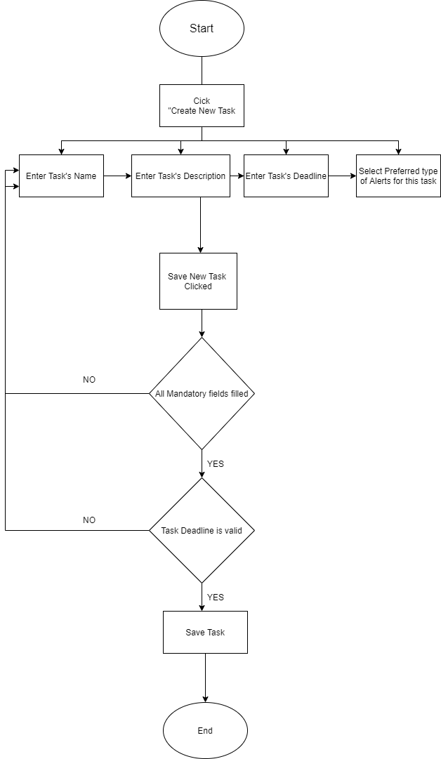

Screenshots

